Develop apply and asses computational methods for analyzing the physical interactions that result from coupling aerodynamics, structural dynamics, and heat transfer.

Accurate enough to for non linear responses.

Efficiency enoughfor multidisciplinary design optimization procedure.

Applicable to problems of reasonable topological complexity including wing strcture or engine aft deck structure with realistic constraints (flutter).

Relevant to many aerospace applications, including structural components expoded to engine heating or heating generated by high aerodynamic speeds.

Structural heating important to understand from several standpoints including controlability, engine integration, stability, and sub-systems.

Developing computational methodologies to capture the relevant multidisciplinary physics, including interface techniques needed to accurately couple the disciplines.

Developing higher order methods (Discontinuous Galerkin) to reduce the number of degrees of freedom needed to model the relevant multidisciplinary physics.

Josh Abstract

Design of structures in high temp environments long been important area of study in aerospace industry

Engine exhast washed structures are investigated

Structural topology optimization is proposed to develop lightweight structures capable of withstanding thermal stresses.

Primary technical contributions to date in this work include an investigation of the effect of nonlinearity, the development of topology optimization-based methods for stiffening thermally loaded structures, and demonstrating the effectiveness of stress-based topology optimization techniques for thermal stresses.

Future work includes applying the methods to structures of greater geometric complexity and incorporating design-dependent temperature loadinginto the topology optimization framework.

---------------------------

Josh Intro

The motivation for the research proposed in this document is twofold.

there exists a lack of appropriate design methodologies for a new class of aerospace thermal structures that are related to low observability aircraft and sustained hypersonic flight vehicles.

Second, within the multidisciplinary optimization community, topology optimization has become the most

active area of research; however, the majority of applications have been restricted to problems of purely mechanical origin.

the proposed work aims to investigate and develop topology optimization formulations suitable for thermal-structural design environments. These developments will then be applied to aerospace thermal structures design problems, specifically engine exhaust-washed structures, to develop structural systems with improved thermoelastic performance.

----------------------

Josh Ch.1

To meet the growing demands for increased mission capability, combat survivability, and versatility of aerospace systems, future military aircraft will continue to rely on low observable technology.

future military aircraft will continue to rely on low observable technology. A critical component of this technology is embedded engine integration, as seen on the current B-2 Spirit stealth bomber and the Efficient Supersonic Air Vehicle (ESAV) concept

utilizing a ducted exhaust system to pass exhaust gases to the rear of the aircraft, direct line of sight into hot engine components is prevented, denying the enemy a vulnerable infrared target.

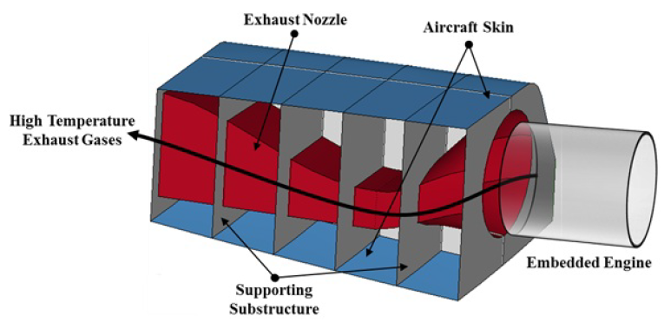

hot exhaust creates an extreme thermal-structural design environment as it is ducted to the rear of the aircraft. In this environment damaging effects of elevated temperatures including excessive deformations, thermal stresses, thermal buckling, and creep may occur.

One of the primary challenges associated with the design of the EEWS is the dominance of low observability design criteria. This places strict geometric shape and fixivity on structural components that

are subject to elevated temperatures. Undoubtedly then, these components are subject to restrained expansion and are susceptible to thermal buckling and thermal stresses. These problems were observed on an exhaust-washed structure on the B-2 bomber known as the aft-deck. In this case, thermal stresses produced cracking and failure in the aft-deck within only a small percentage of its intended life, necessitating costly replacement and retrofitting [16].

these types of design challenges are particularly well addressed using multidisciplinary design optimization techniques, which can simultaneously manage multiple competing responses and arrive at a suitable configuration [17].

------------------------